**1:Create Date class with members day,month ,year.**

**Write no argument and parameterised constructor .Create two object s and initialize them using no argument and parameterised constructor**

**respectively.Print date using display function.**

#include<iostream>

using namespace std;

class date

{

private : int d,m,y;

public :

date()

{

cout<<"Date inside default constructor "<<endl;

d=1;

m=6;

y=1990;

}

date(int d , int m , int y)

{

cout<<"Date inside parameterised constructor"<<endl;

this->d = d;

this->y = y;

this->m = m;

}

void display()

{

cout<<"DATE - "<<d<<"/"<<m<<"/"<<y<<endl;

cout<<endl;

}

};

int main()

{

date d;

d.display();

date c(21,6,2001);

c.display();

}

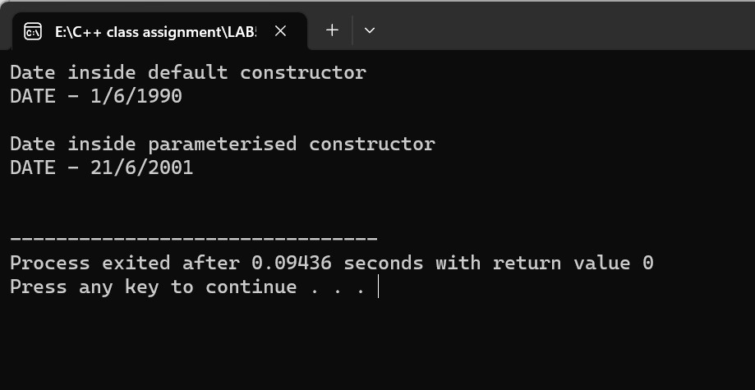

**2:Create Employee class with members id(int),name(string),dob(Date).Use above created Date class.**

**Write default and parameterised constructor in Employee Class.Write accept() function to accept information and display() to display emp information.**

#include<iostream>

using namespace std;

class date

{

private : int d,m,y;

public :

void accept()

{

cout<<"\nEnter day month and year "<<endl;

cin>>d>>m>>y;

}

void display()

{

cout<<endl<<"\nDATE - "<<this->d<<"/"<<this->m<<"/"<<this->y;

}

};

class employee : public date

{

int empid ;

string name;

public :

employee()

{

empid = 101;

name = "Ram";

}

employee(int empid , string name)

{

this->empid = empid;

this->name = name;

}

void display()

{

date::accept();

date::display();

cout<<"\nName of employee - "<<name;

cout<<"\nID of emloyee is - "<<empid;

}

};

int main()

{

employee e(204,"Ashok");

e.display();

}

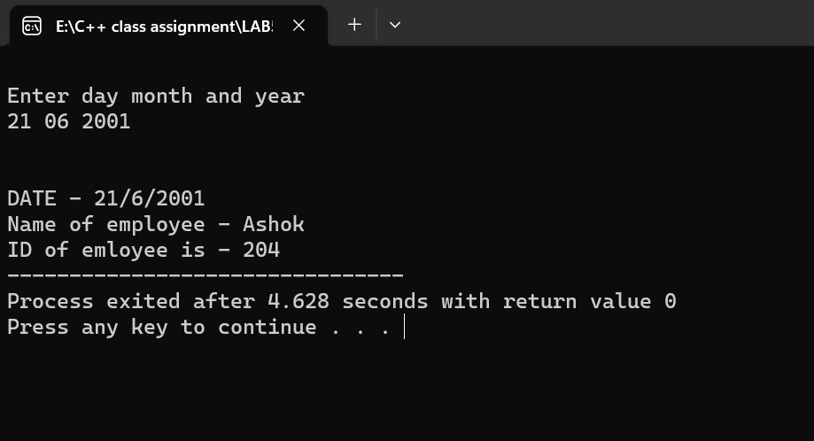

**3:Consider that payroll software needs to be developed for computerization of**

**operations of an ABC organization. The organization has employees.**

**3.1. Construct a class Employee with following members using private access**

**specifies:**

**Employee Id integer**

**Employee Name string**

**Basic Salary double**

**HRA double**

**Medical double=1000**

**PF double**

**PT double**

**Net Salary double**

**Gross Salary double**

**Please use following expressions for calculations://Note:Don't accept HRA,PF PT from user**

**\* HRA = 50% of Basic Salary**

**\* PF = 12% of Basic Salary**

**\* PT = Rs. 200**

**3.2. Write methods to display the details of an employee and calculate the gross**

**and net salary.**

**\* Goss Salary = Basic Salary + HRA + Medical**

**\* Net Salary = Gross Salary – (PT + PF)**

**Create Object of employee class and assign values and display Details.**

#include<iostream>

using namespace std;

class employee

{

int empid;

string empname;

double salary,ha,medi,pf,pt;

public :

employee(){

empid = 100;

empname = "Rahul";

salary = 10000.00;

ha = 0.0;

pf =0.0;

pt =200.0;

medi = 1000;

}

employee(double salary,int empid,string empname){

this->salary = salary;

this->empid = empid;

this->empname = empname;

}

void display()

{

ha = (5.0/100.0)*salary;

pf = (12.0/100.0)*salary;

double x = this->salary + ha + pf;

cout<<"\nEmployee name is - "<<empname;

cout<<"\nEmployee ID - "<<empid;

cout<<"\ngross salary of an Employee is - "<<x<<"/-";

cout<<" \nNet salary of an Employee is "<<salary - (pt+pf)<<"/-";

}

};

int main()

{

employee e(10000,401,"Rakesh");

e.display();

}

